To Enable Delay of 4hours before deployment use **Gates**

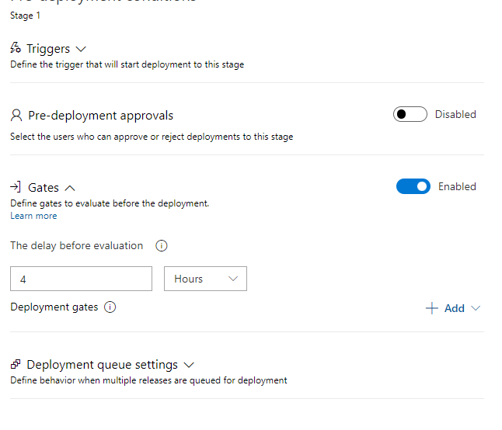

Make Sure Deployment trigger for stages is **Manual only** as our **Script1.ps1** will be stage based script

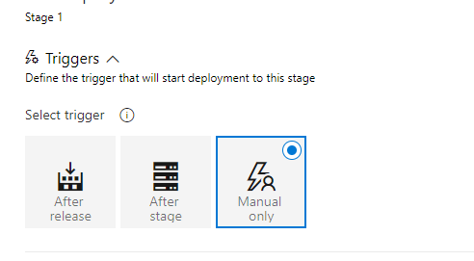

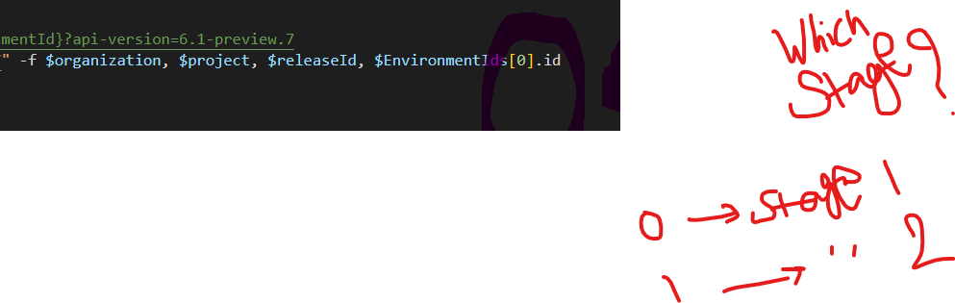

Refer in **script1**

